Break Time is a café that sells many kinds of tea. You, as an IT Manager Department, are asked to build an application to record Break Time’s selling history data. You are required to use file management in developing this application. Here are the detail requirements:

* At first, program will read all selling data from **“data.txt”,** including product’s name, topping, size, and price.
* Program consist of 5 menus:

1. **Buy Break Time Tea**
2. **View History**
3. **Sorting Ascending by Price**
4. **Exit**



* When user chooses **Buy** **Break Time (Menu 1)**, then:

1. Program will ask user to input tea name. Validate the **input must be Olong, Green Tea, or Jasmine**
2. Program will ask user to input the topping. Validate **the input must be Bubble Jelly, Coffee Jelly, or Grass Jelly**
3. Program will ask user to input the size. Validate the **input must be 8, 12, 16, or 18**
4. Program will **show the Detail Purchase**, such as Break Time **tea name, topping, size, and price**. The price is calculated using the following formula:

**Price = size x length of tea name x length of topping x 20**

In example:

Name : Green Tea

Topping : Bubble Jelly

Size : 12

Price : 15920

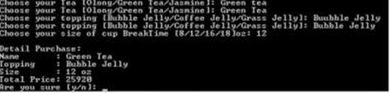

1. Program will ask user’s confirmation. Validate the input **must be the character of ‘y’ or ‘n’**. If user inputs ‘y’, add the inputted data into selling history data list. But, if user chooses ‘n’, program will go back to main menu.

* When user chooses **View History (Menu 2)**, program will show selling history data in this **format: No, Name, Topping, Size, and Price**.

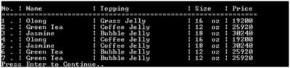

* When user chooses **Sort Ascending By Price (Menu 3)**, program will show selling history data which has been sorted in ascending order according to their price.

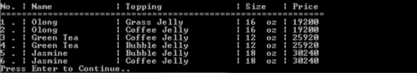

* When user chooses **Exit (Menu 4)**, program will **write the data into data.txt** and program will end.